****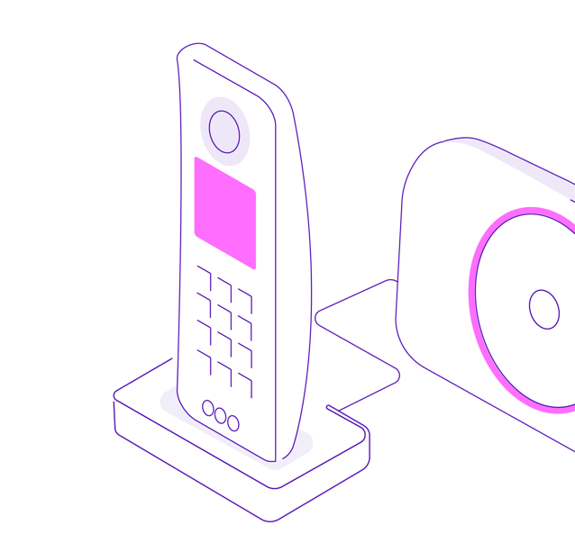SSSSSCSSSSSS SSSSSS

Landlines in the UK are going digital by the end of January 2027.

Although the landline isn’t going away, we know that you might have questions or would like to know more about this industry-wide change.

We'd love to talk to you about the UK's switch to digital landlines and will be visiting local towns and communities near you, where a member of our team will be on hand to tell you what Digital Voice is, why the change is necessary and what it means for you.

You don’t have to pre-book, just turn up.

Where and when:

We’re holding a drop-in session on the **16th of September between 10:00 and 16:00 in the BT Truck, Pye Gree Community Centre Car Park, Bradbury Lane, Cannock WS12 4EP**

Digital Voice is coming to a town near you

Come and speak to us about our new home phone service, Digital Voice

**For more information, visit** [**www.bt.com/digitalvoice**](http://www.bt.com/digitalvoice)

Come and speak to us about our new home phone service, Digital Voice